**G Motors SQL Question and Answers**

1. List the top 3 and bottom 3 makers for the fiscal years 2023 and 2024 in terms of the number of 2-wheelers sold. 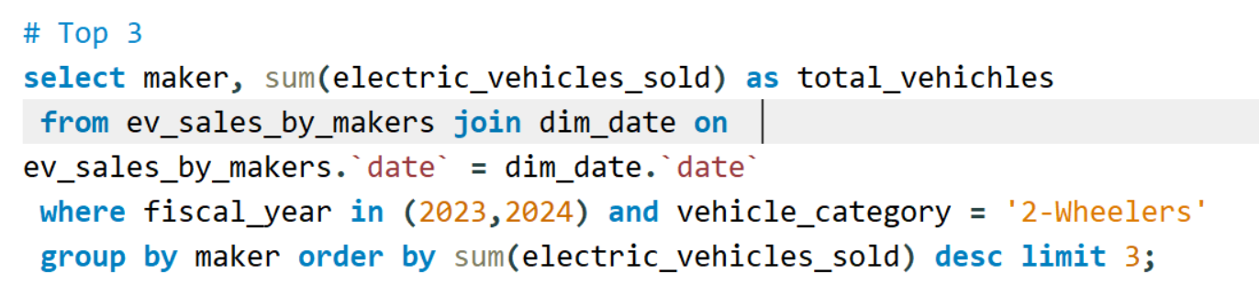

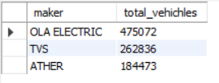

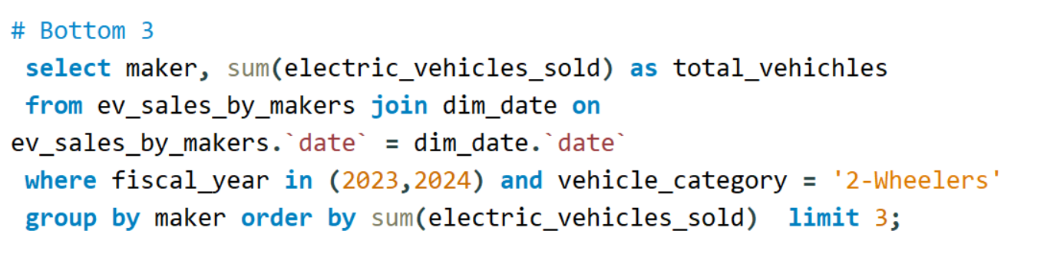

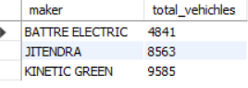

1. Find the overall penetration rate in India for 2023 and 2022





1. Identify the top 5 states with the highest penetration rate in 2-wheeler and 4-wheeler EV sales in FY 2024.

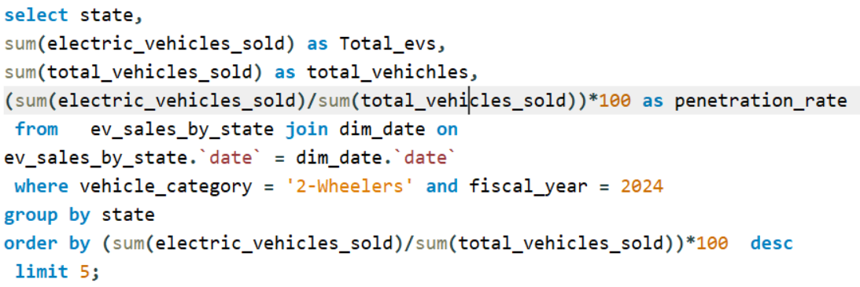

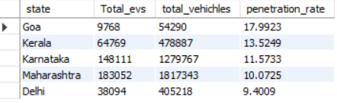

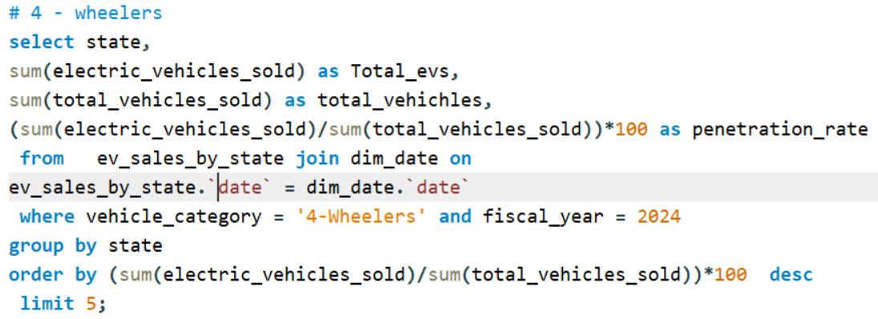

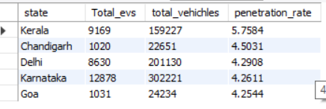

1. List the top 5 states having highest number of EVs sold in 2023

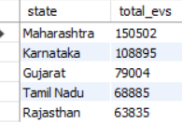

1. List the states with negative penetration (decline) in EV sales from 2022 to 2024?

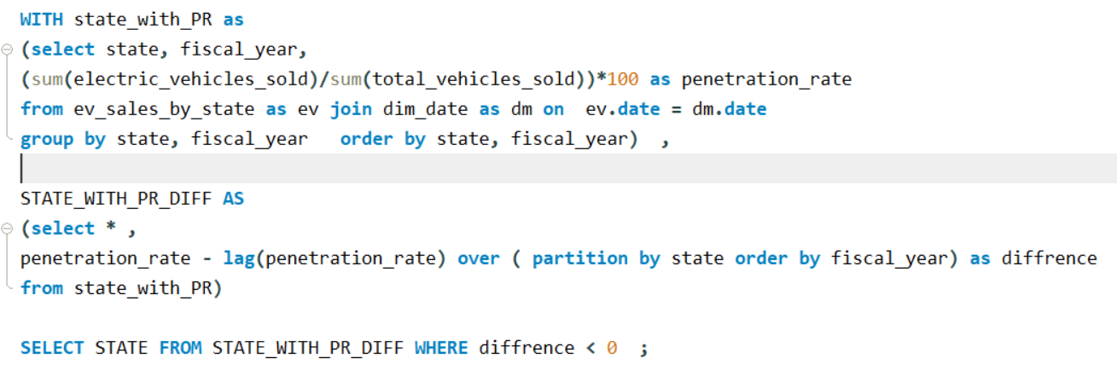

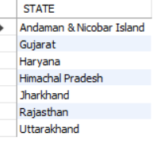

1. Which are the Top 5 EV makers in India?



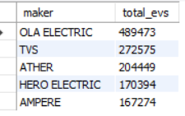

1. How many EV makers sell 4-wheelers in India?





1. What is ratio of 2-wheeler makers to 4-wheeler makers?

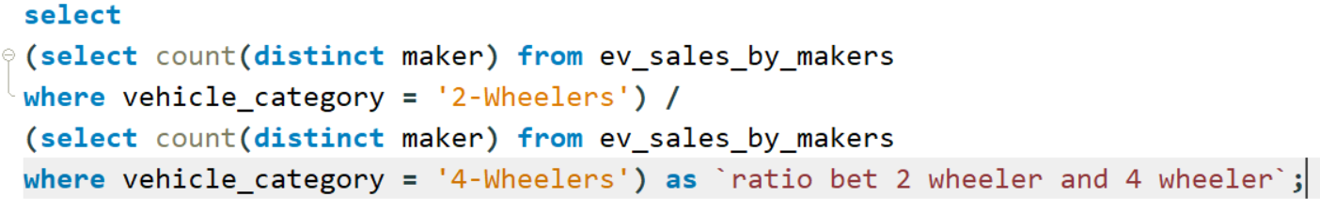

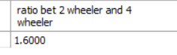

1. What are the quarterly trends based on sales volume for the top 5 EV makers (4-wheelers) from 2022 to 2024?

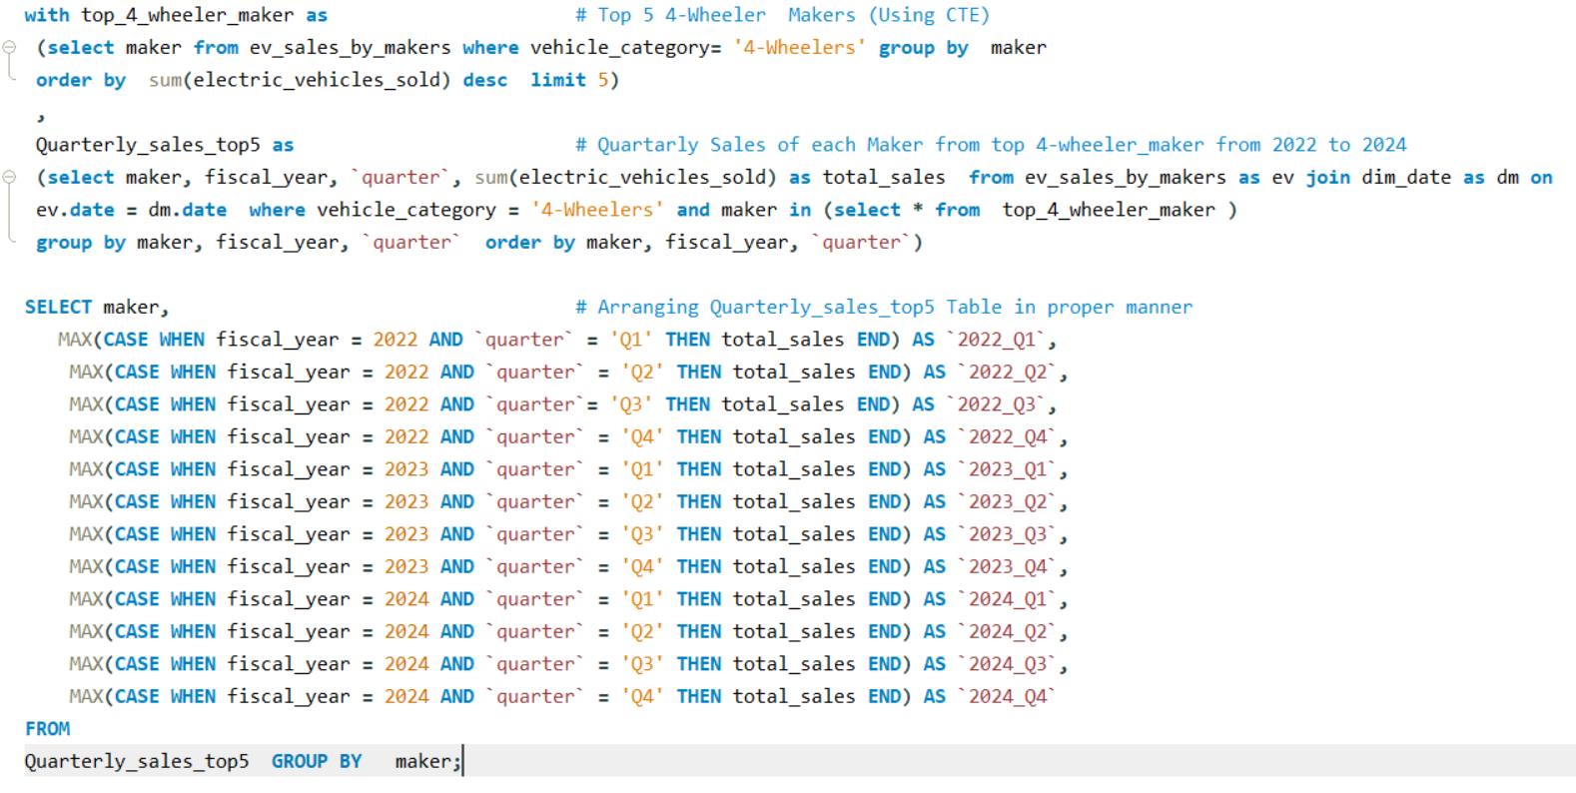

Answer of 9th Question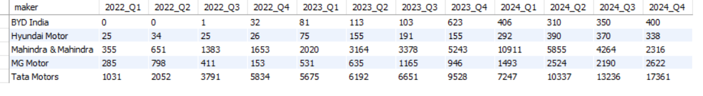

1. How do the EV sales and penetration rates in Maharashtra compare to Tamil Nadu for 2024?

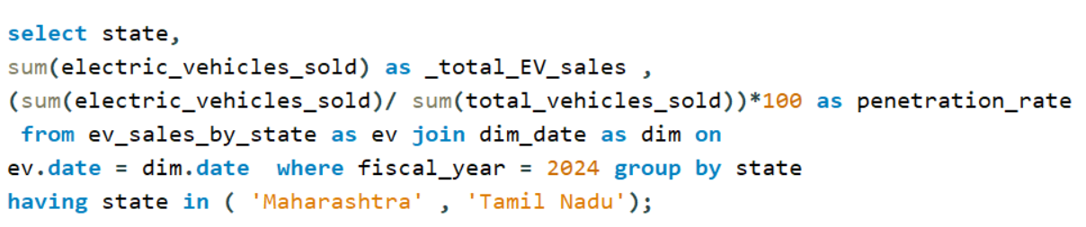

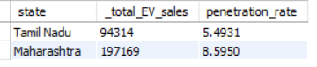

1. List down the compounded annual growth rate (CAGR) in 4-wheeler units for the top 5 makers from 2022 to 2024.

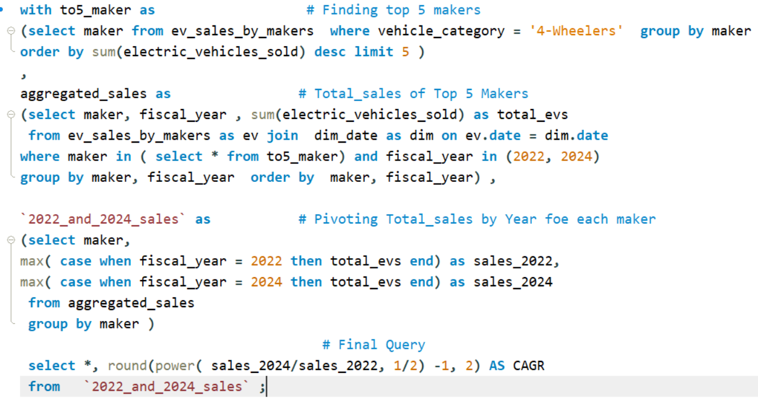

Answer of 11th question

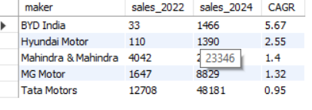

1. List down the top 10 states that had the highest compounded annual growth rate (CAGR) from 2022 to 2024 in total vehicles sold.

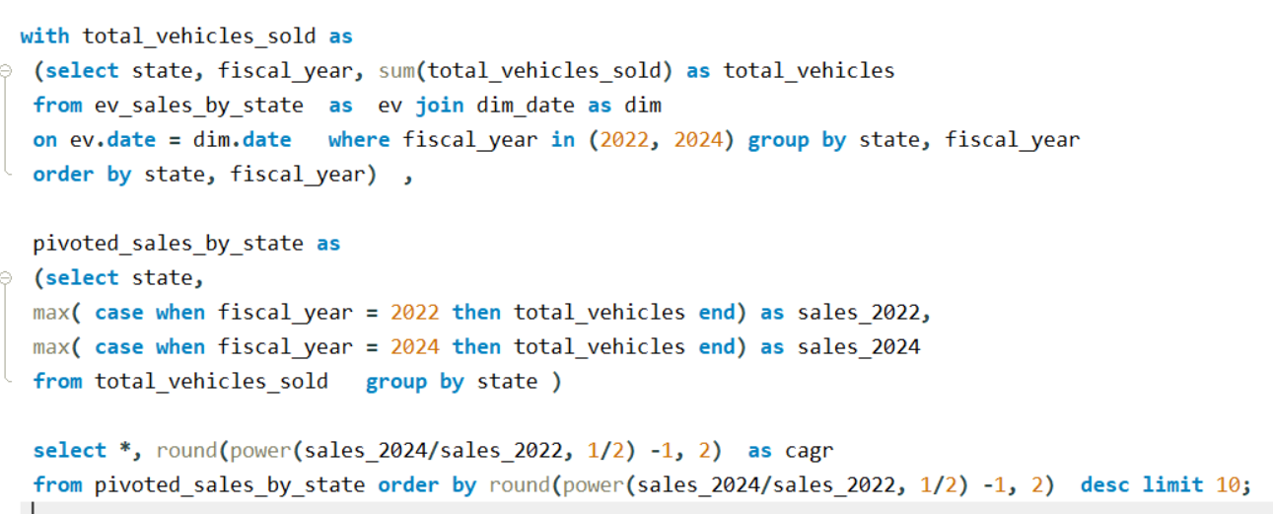

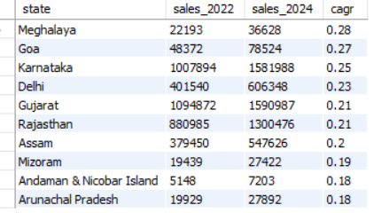

1. What are the peak and low season months for EV sales based on the data from 2022 to 2024?

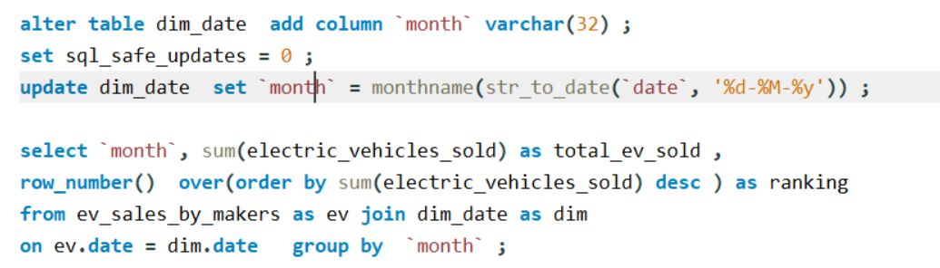

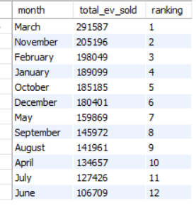

1. Estimate the revenue growth rate of 4-wheeler and 2-wheelers EVs in India for 2022 vs 2024 and 2023 vs 2024, assuming an average unit price.

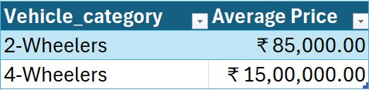

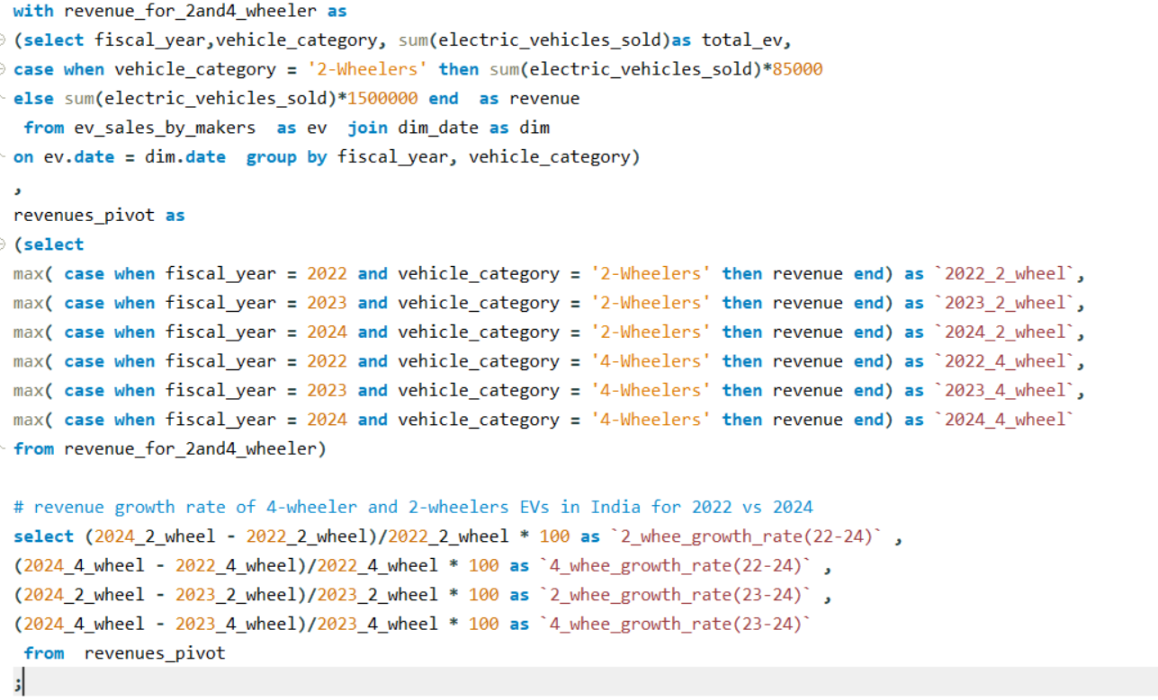

Answer of 14th question

